**PropTypes - Images**

**Index.js:**

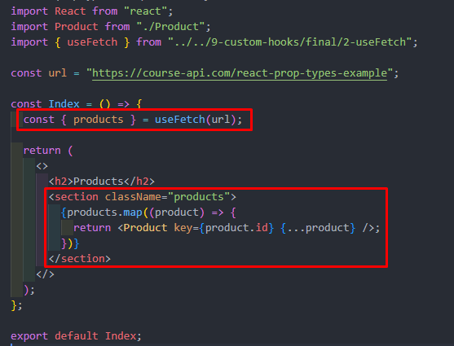

But problem ta hobe tokhon e jokhon kono property er konoo value missing thakbe,

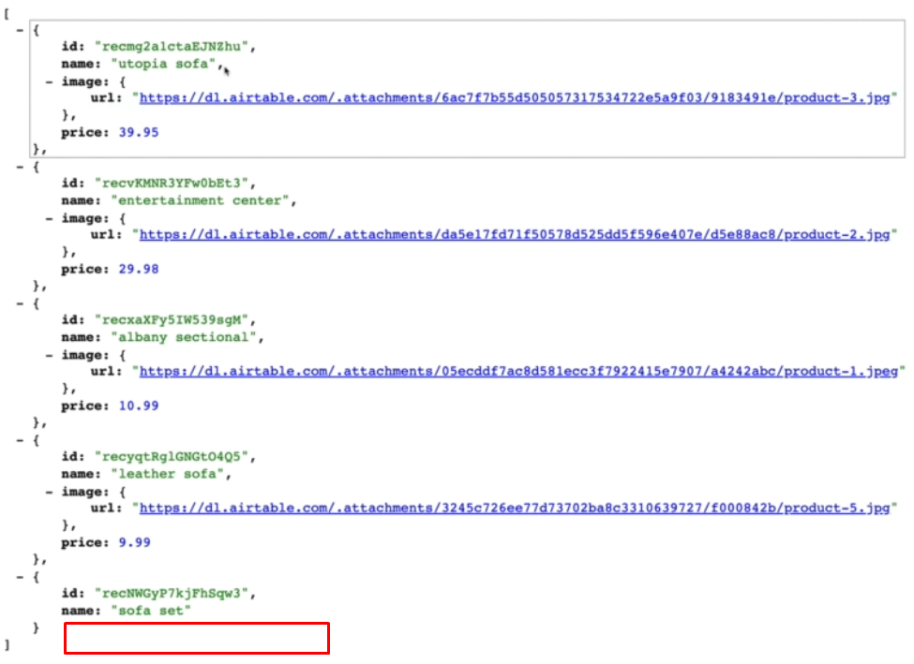

Ekhane jemon image r price missing. So, jokhon map() use kore shob gulo property visit kore object-destructuring korbo then error create korbe.

**Product.js:**

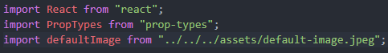

1. **First PropTypes import korte hobe.**
2. **Er maddhome amra propTypes and defaultProps peye jabo.**
3. **propTypes er moddhe type declare kore dibo.**
4. **defaultProps er moddhe default value set kore dibo**

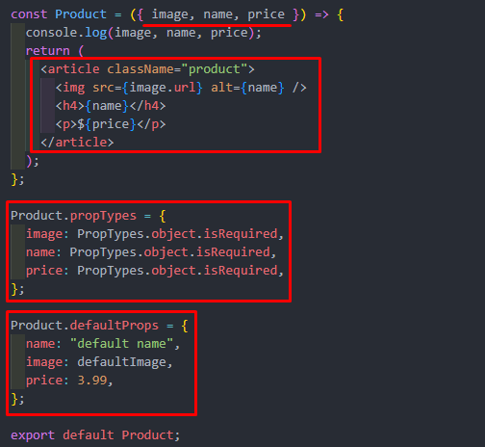

**PropTypes - Default Values**

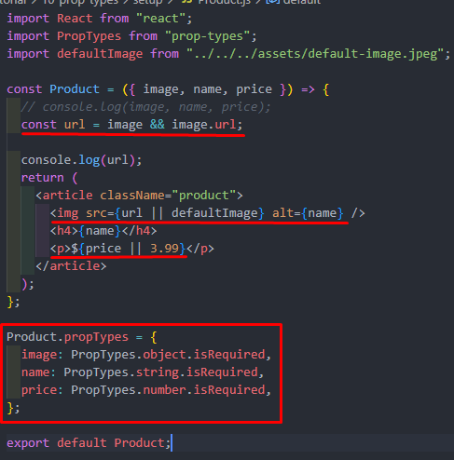





Ekhane eta use kora jabe na tahole error ashbe. Cz image er vitore jeye JS read korte pare na.